Environmental Literacy Biodiversity Assessment:
--- High School Level ---
Park and Forest
Science is easier to understand if you can make connections between what you know now and the new ideas that you are studying. This is a test that will help us to understand what you know now. Please answer these questions as carefully and completely as you can. If you are not sure of the answer, please write about any thoughts that you have. If you can help us to understand how you think about these questions, then we can do a better job of explaining science in ways that make sense to you.

Please put your initials (not your full name) in the boxes
Date ________________ | First | Middle | Last
Class ____________________________ Teacher _______________________

The two pictures below show a park. Picture A shows the north side and Picture B the south side of the same park. Looking at both pictures, respond to the questions that follow.

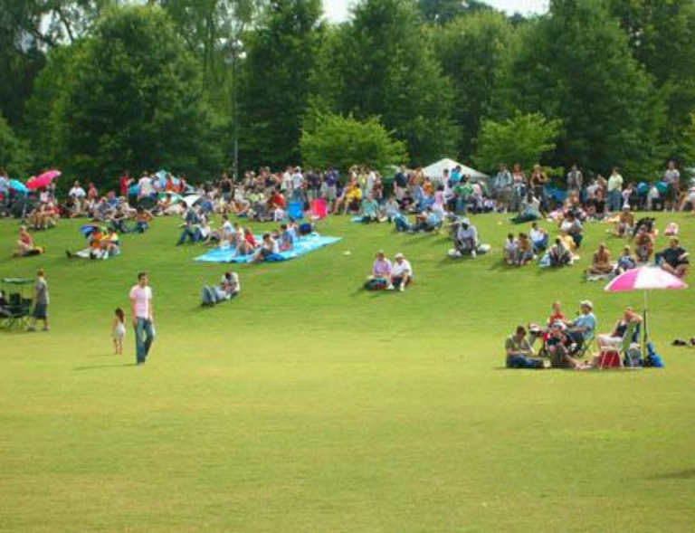
5a
5b
5c
Picture A – North side of park

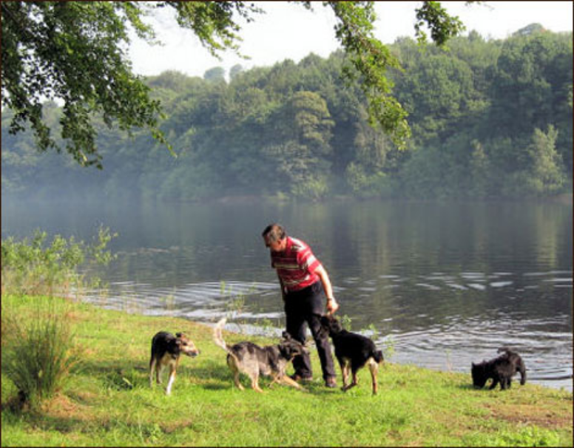
Picture B – South side of park

1. In picture A you can see a neat lawn where people are having picnics. In the background behind the people there is a forested area with different trees and shrubs. Both grass from the lawn and trees from the forested area produce seeds that are carried by the wind and scattered everywhere.

- Why do you think that very little grass is growing under the trees, even though some grass seeds sprout under the trees?

b. Why do you think there are no trees growing in the lawn, even though some tree seeds sprout in the lawn?

c. What do you think that people (including park groundskeepers, visitors, etc.) are doing that makes grass grow well and trees grow poorly on the lawn?

2. Among the picnickers in Picture A are the following people:
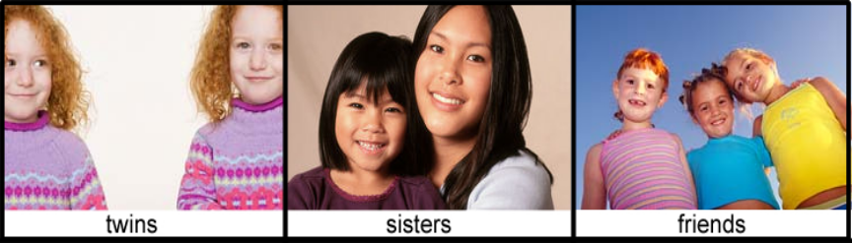
I
II
III

a. Which of the above pictures show twins? How are they alike and different?
Alike:

Different:

b. Which of the above pictures show friends? How are they alike and different?
Alike:

Different:

c. Which of the pictures show sisters? How are they alike and different?
Alike:

Different:

d. Suppose you have blood samples of the two individuals in picture II. How would you figure out their relationship (twins, sisters, or friends) from the blood samples?

3. In picture B you see a man with four pet dogs. Three of the dogs are German Shepherds and one is a Cairn Terrier. These dogs are all descended from wolves as are other dog breeds shown in the picture below:

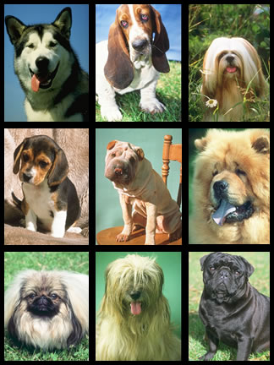
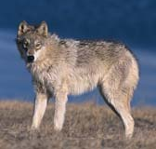

How could dogs that live with humans become so different from one another and from wolves?

4. In the background of Picture A, there are three trees 5a, 5b, and 5c that look like one another. Suppose you are a scientist who is asked to determine how closely the trees are related to one another, for example, if they all have the same parents. Name two tests or observations that you could make to decide how closely the trees are related and what evidence you would look for in each one.

a (i). Suppose you could observe and handle the trees. What would your first test or observation be?

a (ii). What evidence would it give you about how closely the trees are related?

b (i). Suppose you could not handle the trees but were given samples of tree wood, bark, and leaves. What tests or observations would you make on the tree samples?

b (ii). What evidence would these tests or observations give you about how closely the trees are related?

5. Look at picture A. What do you think will happen to the lawn and to the forested area if humans abandoned this park completely?

Lawn:

Forested area:

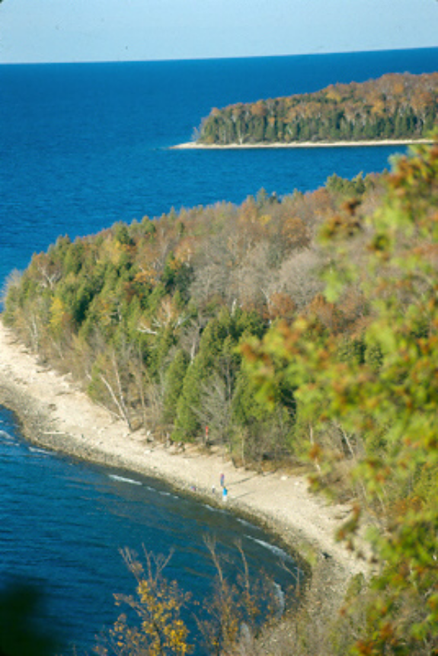
Picture C (to the left) - The land area in this picture used to be only sand dunes. It did not have any beech or maple trees. Below, Pictures D, E, and F are close-ups of different parts of this land.
Picture B (below) – This is

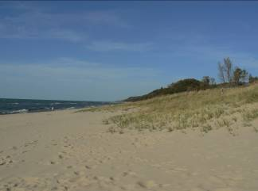
Picture D (below) – This is a close-up picture of the sand dunes.

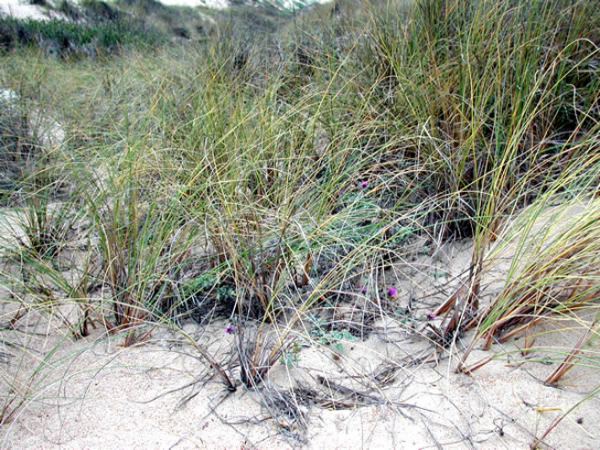
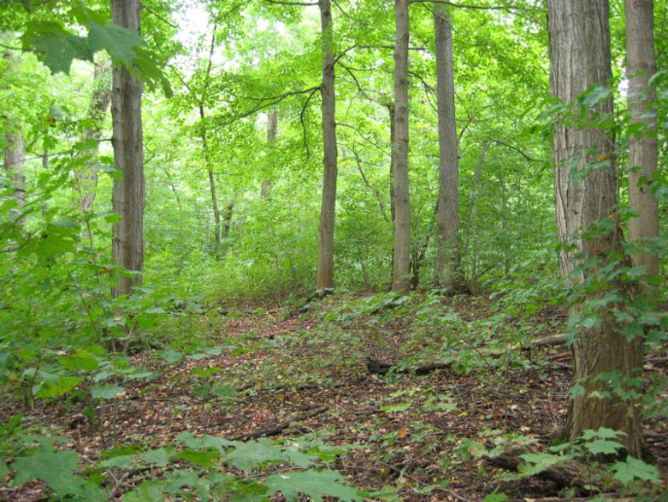
Picture E – This is a close-up picture of some grasses in the sand dunes close to the water.
Picture F – This is a close-up picture of the beech maple forest.

6. Pictures D, E, and F are close-ups of different parts of Picture C. Both grasses from the beach and trees from the forested area produce seeds that are carried by the wind and animals.

a. Some tree seeds land in the sand on the beach. But there are no trees growing close to the water (on the beach). Why do you think there are not trees growing on the beach?

b. Picture E shows some grass growing in the sand dunes. You find lots of grass growing in the sand dunes. But you do not find much grass growing in the forest, even though some grass seeds sprout under the trees (Picture F). Why do you think there is not much grass in the forest?

6c. Picture F shows a beech maple forest. Why are there so many species of plants and trees in a beech maple forest? Why don’t one or two species take over the entire area?

7. Beech and maple seedlings grow well in shade. Cottonwood seedlings, on the other hand, grow better with more sunlight. Here is a story of how the forest grew on the sand dunes.

Year 0: Beginning of forest growth. A part of the sand dunes became sheltered from the wind and waves. At first it had only beach grasses like in Picture C above and shrubs. Some cottonwood, maple, and beech seeds fell among the grasses and started to grow.

Year 20: Growing forest. The tallest trees were mostly cottonwoods around 20 years old. There were some beech and maple seedlings under the cottonwoods, but they were all small and less than 10 years old.

Year 100: Beech-maple forest. The forest looked like Picture D. The tallest trees were mostly beeches and maples. There were no cottonwood trees growing in the forest.
Use the information above to help you explain why after 20 years, the tallest trees were cottonwood, but after 100 years the tallest trees were beech and maples.

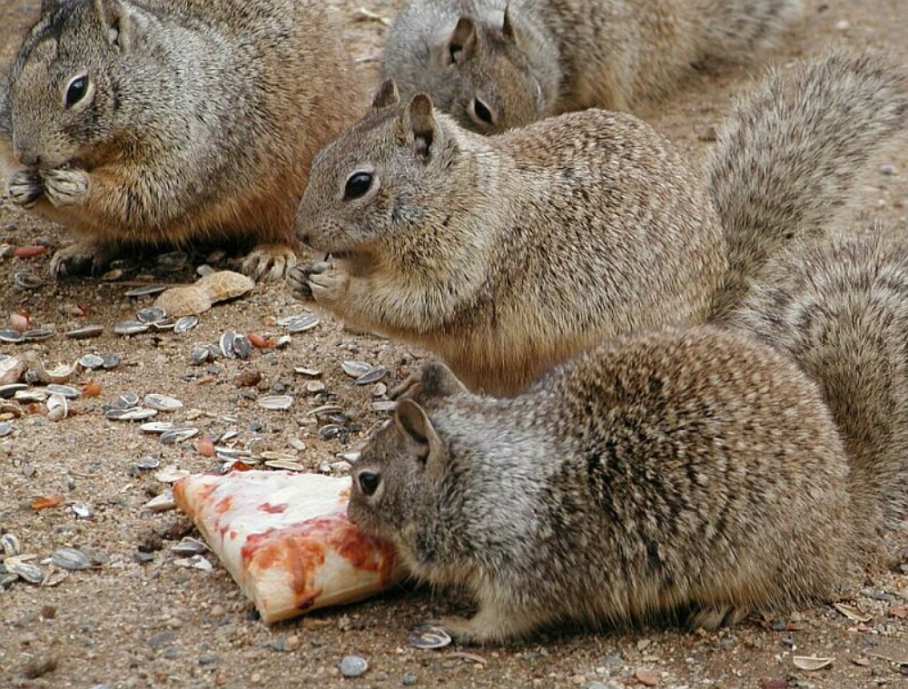

b

a

c

Picture G – Squirrels that live in the beech maple forest

8. As the land in Picture C gradually changed from sand dunes to a forest, squirrels began to inhabit the forest.

a. Why do squirrels live in the forest and not in the sand dunes? What does the forest have that helps the squirrels survive? What do the sand dunes not have that the squirrels need to survive?

b. Before it was a forest, chipmunks lived in the area. Now, there are fewer chipmunks and more squirrels. Why are there fewer chipmunks now? Why are there more squirrels?

9. In the picture G, there are three squirrels a, b, and c that live in the forest and resemble one another. Suppose you are a scientist who is asked to determine how closely the squirrels are related to one another. Name two tests or observations that you could make to decide how closely the squirrels are related and what evidence you would look for in each one.

a. Suppose you could observe the squirrels, but not handle them. How could you test to see how close they are related? What would you observe?

b. Suppose you had blood samples from the squirrels. How could you test the blood samples to find out how closely they are related? What could you test?

10. Squirrels have claws that they use to help them climb the bark of trees and jump from branch to branch. They had ancestors that did not have good claws, so they were not as good at climbing and jumping. Explain how modern day squirrels have claws that are good for climbing and jumping even though their ancestors did not.

